Files needed for the Assignment:

You will need the additional Datafiles homework. The files are located in the classdata\additional datafiles\Custom Lists and Libraries folder on the network drive.

**Download this document and add screenshots and answers to the questions.

Log into the CS Team site

1. Create a new Document Library named Team Meetings

a. Set: Create a new version when edit a file. Printscreen when set the settings.

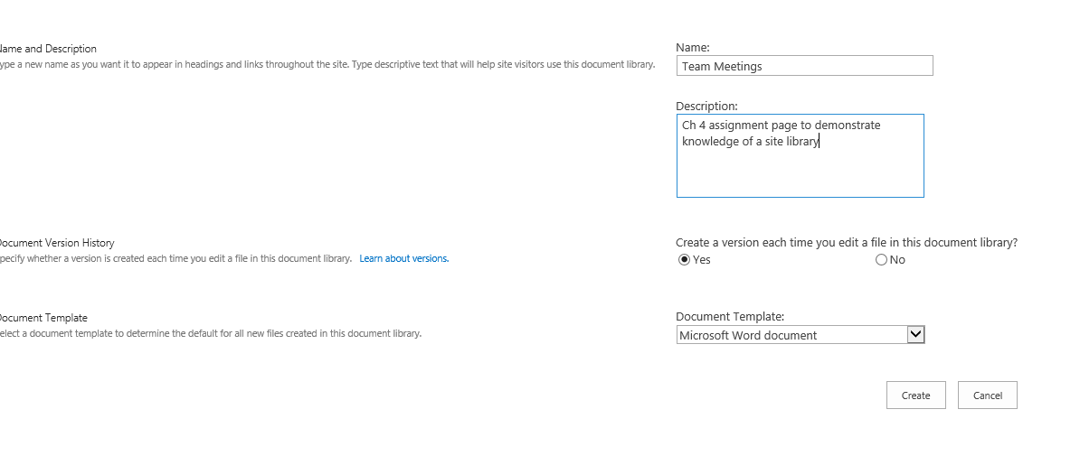

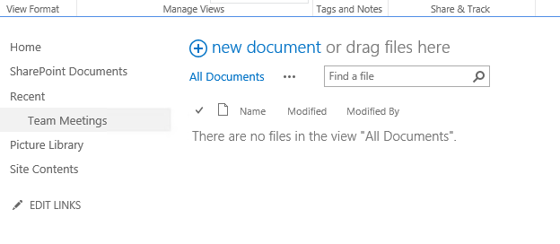

2. Add Three new **site columns **I must be able to see that they are site columns.**

a. Requested By, this will be a user in Active Directory

b. Date Submitted datetime required

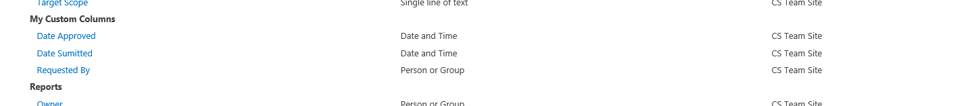 c. Date Approved: date time  
 Printscreen showing the site columns   
  
  
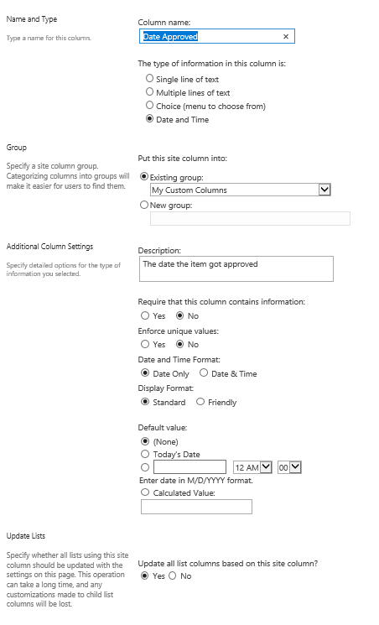

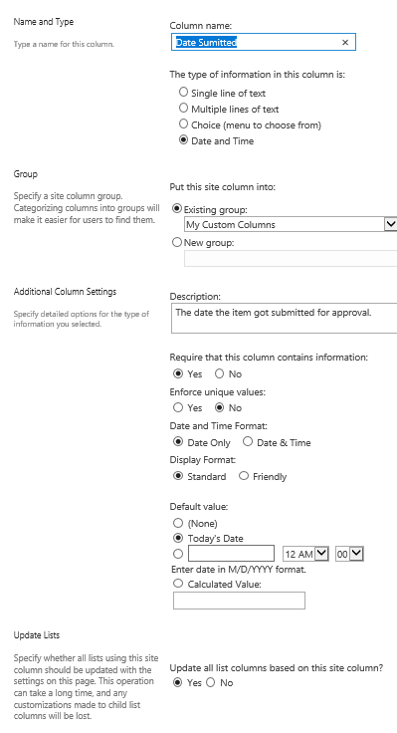

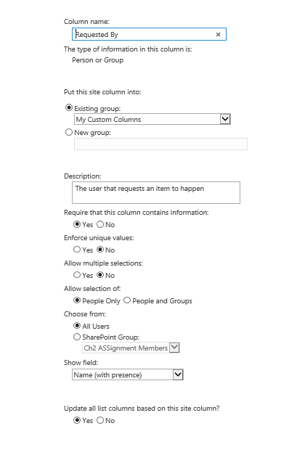

3. Why would you create the columns as site columns?  
  
The main reason to use site columns is the ability to reuse the same information that the column provides without having to make duplicates each time the information is needed on the main page or one of the team pages. The one that I think of that is always the same is the drop-down to choose a state/providence/territory/armed forces base. The information is not changing much (maybe the different armed forces bases, but the states and providences are not). The state dropdown could be used on the employees contact info site, client contact info site, customer web interface site, etc.

4. Add the newly created site columns to the Team Meetings doc library

. Printscreen showing the columns added to the Team Meetings doc library.  
  
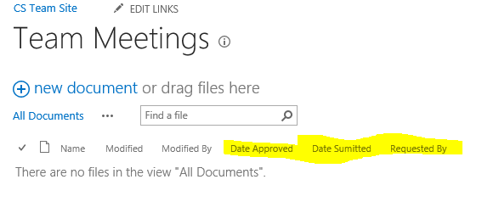

5. Add the meetingAgenda.docx document as the Team Meetings document library **template**. \*\**Can only open in Explorer view using Internet explorer*

Printscreen Team Meeting Library settings > Advanced settings page   
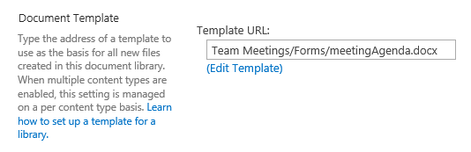

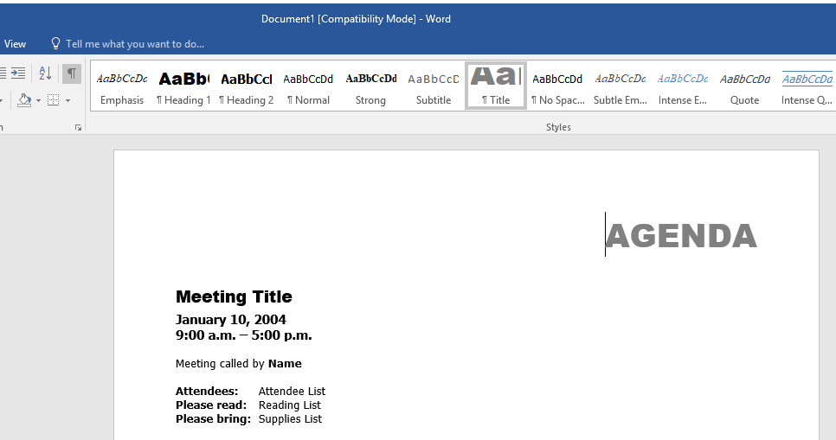

6. . What is the benefit of adding a specialized document template to a document library?

The benefit of a custom document template is the ability for a special document library like meeting notes to be able to access the organizations approved template for notes which is easier than hunting down the network drive or system drive for the template, and don’t have to get the old minutes do a save as and then go over it. The overall benefit is the ability to give the least technical people one place to access and then be able to upload it back into the shared company/team site.